Biography - Lonnie Riley
In 1999 the Lord called Lonnie and Belinda Riley to Lynch, KY to help people and share Jesus. They had no preconceived plan or strategy, but the Lord supplied. Now a multifaceted ministry is in place with many ministries in place as tools to share Christ.
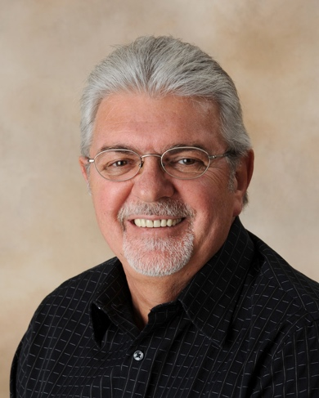
Ministries include:
- Solomon’s Porch Retreat Center
- Black Mountain Exchange
- Lamp House Coffee Shop
- Meridzo Agribusiness Center (Mushroom growing facility)
- The Stables at Creekside Glen
- Shekinah Village
- Hope House
- Calvary Campus at Blackey
- Maytown Center at Langley
- Heaven’s Door Chapel at Lake Cumberland Resort
And other personal ministries
​
Lonnie and Belinda have served as college Administrators, State Convention Staff, Pastor of small and large churches.

Trustee of New Orleans Baptist Theological Seminary (2 Terms)

Named 2004 Missionaries of the Year by NAMB for the U.S. and Canada

Received Tony Turner Award and the Community Development Award by the Tri-Cities Chamber of Commerce.

Received 2017 Governor’s William Cooper award for Faith and Community Impact.

Many other awards and recognitions have been given.

